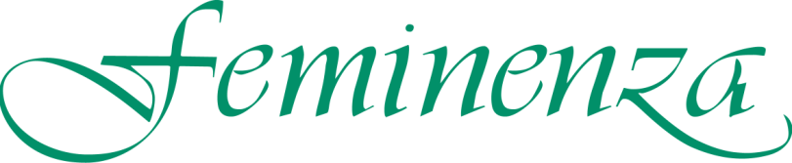



Feminenza Kenya
Annual Activity Report 2018

Chairperson’s Introduction

Welcome to our 2018 activity report.

2018 was a year of continuing to work on the requirements for Feminenza Kenya to transition to charitable status. Part of this was to get fully audited accounts for the years 2013 up and until 2016 and getting them filed with the KRA.
Various funding proposals were prepared, notably one with the Rotary club in the United Kingdom and the Rotary Club in Nakuru, and contacts were made with GIZ (German International Development Fund) but it did not result in concrete projects. Most of these initiatives were developed with Agnes Mwamburi, member of Feminenza and promoter of its works in Nakuru County.

The Quarterly meetings of the full Board were dedicated to fashioning a new strategic plan for Feminenza Kenya. One of the elements, which was taken into account, was the Forgiveness initiative started by the President of Kenya, in March 2018.

Monique Weber
Chair Feminenza Kenya

Organisational Development

Governance

We re-appointed DMG Associates as our auditor and Kevin Mbugua as our book keeper and started to review the Memorandum & Articles of Association of Feminenza Kenya in light of the transition to charitable status.

Finance

We have continued with the services of our Book Keeper, Kevin Mbugua, who completed the accounts for the years 2017 which were submitted to the Auditor Dominic Mirie. Dominic concluded the audit of our accounts 2013 – 16 and they were signed off by the board. This brought us up to date with the accounts since one of our Directors, Janny Slagman, passed away.

The opening balance of the Feminenza Kenya account in 2018 was KES 642,434.95 and the closing balance was KES 20,933. There was no income for the first 11 months of the year. Expenditure consisted of bank fees, taxes, legal and accountant fees and reimbursement to Stichting Feminenza in the Netherlands for advancing the expense for the 2017 5-Day Trauma Healing Workshop in Nakuru. At the end of the year we had to request a grant of approx. KES 52,000.00 from Feminenza International to meet our expenses for 2018.

Fundraising

Feminenza Kenya and Mrs Agnes Mwamburi (one of our 2010-2011 training programme alumni and Feminenza member) produced various proposals to be able to conduct more Trauma Healing Workshops in Nakuru County for youths, women and men and to offer the Trauma Healing Practitioner Training programme for which an interest has been expressed by leaders of Nakuru County.

None of the proposals led to concrete projects, but were very useful in the sense of raising the awareness about Feminenza’s programmes.

Logistics

Logistic activities consisted of travel and accommodation arrangements for the Nakuru Trauma Healing Workshop.

Feminenza Kenya’s Public liability insurance was renewed with Eagle Africa due to the public activities in 2017.

There were no Security or Health and Safety issues in 2018.

Project Work

No projects materialized in 2018.
Signed on behalf of the Feminenza Kenya Board

M. Weber (Chair)

